**Geometry Optimizer Using Min Thickness Seed**

Stats:

Total time: ~3.6 hours (82% of time used by DirectStiffnessSolver.m)

Total frames analyzed: 1,000,000 (250,000/optimizer)

Sequence:

1. Min thickness seed 🡪 geometry optimizer(2,0.5,2) 🡪 weight optimizer
2. Min thickness seed 🡪 geometry optimizer(0.5,2,0.5) 🡪 weight optimizer

**NOTE: Pics on left are the original 2017 frame for reference!**

**GeoOptimizer #1:**

For this sim, X and Z could vary by up to 2” in either direction and Y was allowed to vary by up to 0.5” either way.

Generation Best Ratio: 26.8849

Associated Stiffness: 1329.4002 N*m/deg

Associated Weight: 49.4478 lbs

ISO

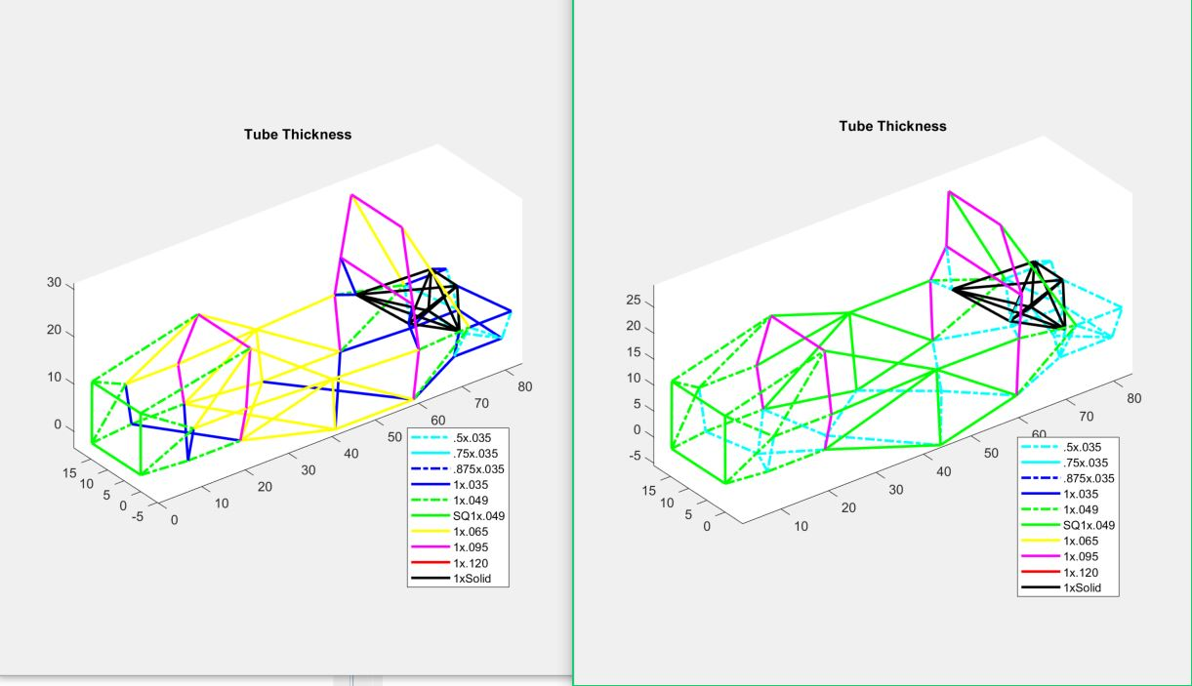

TOP

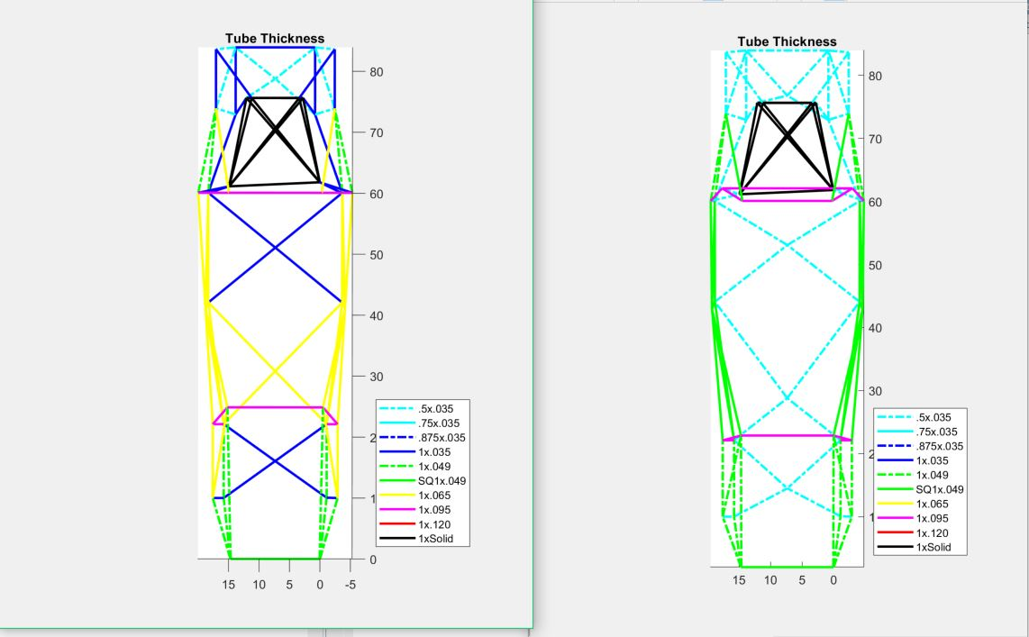

SIDE

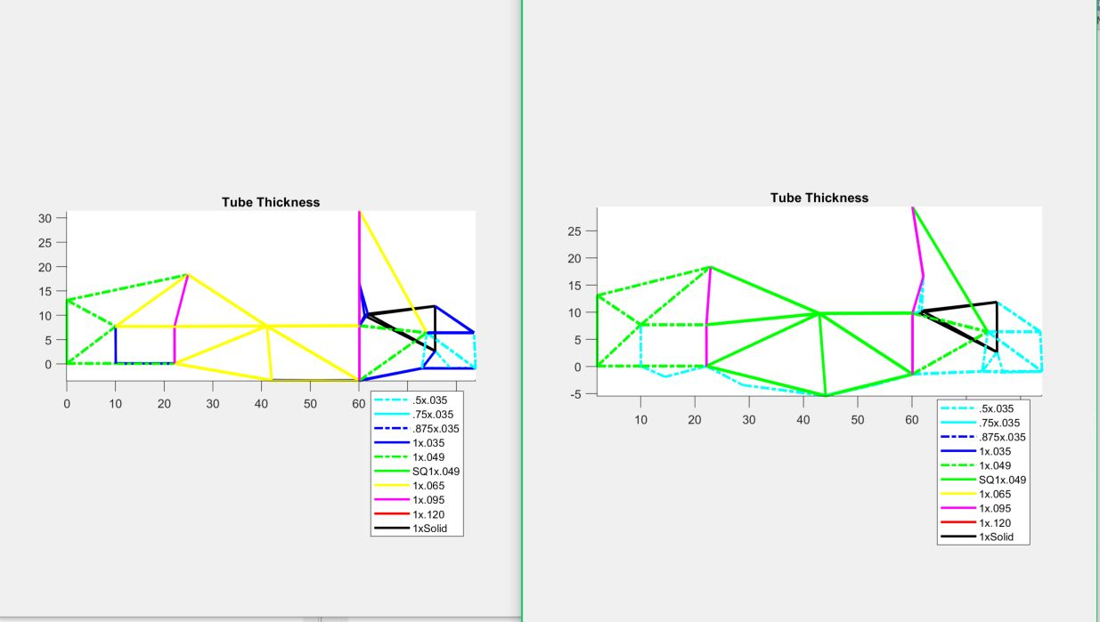

**WeightOptimizer #1**

Generation Best Ratio: 27.3853

Associated Stiffness: 1390.91 N*m/deg

Associated Weight: 50.7904 lbs

ISO

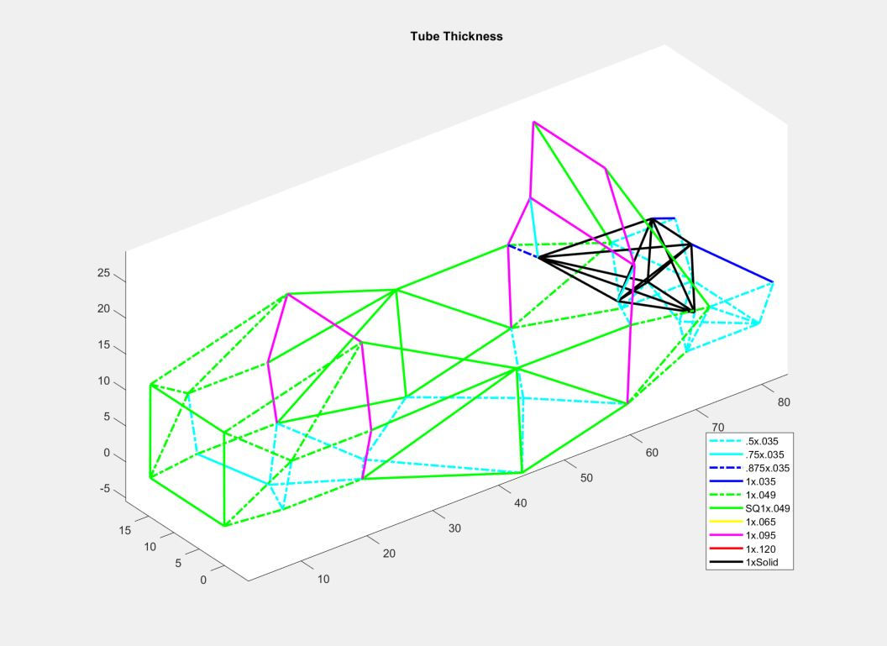

**GeoOptimizer #2**

For this sim, X and Z were allowed to vary by up to 0.5” in either direction and Y was allowed to vary by up to 2” either way.

Generation Best Ratio: 38.7078

Associated Stiffness: 1918.6764 N*m/deg

Associated Weight: 49.5682 lbs

ISO

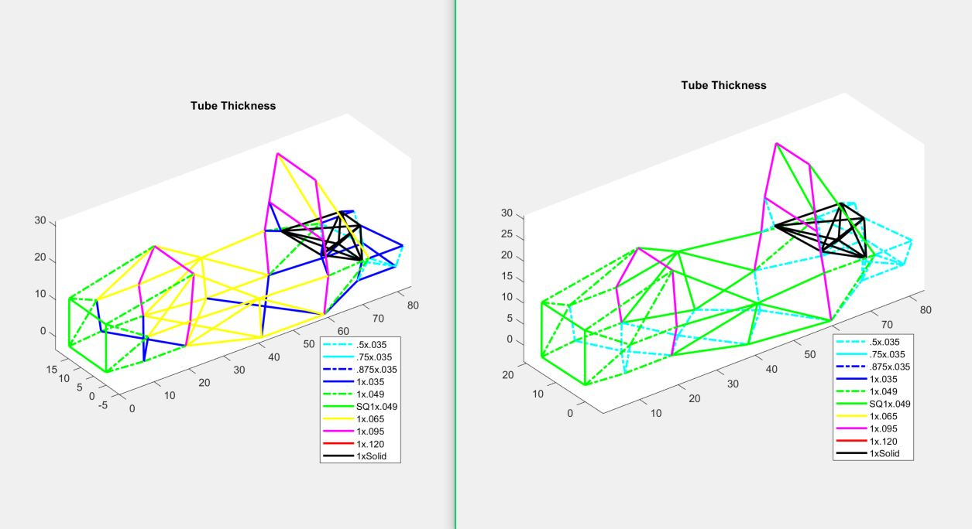

TOP

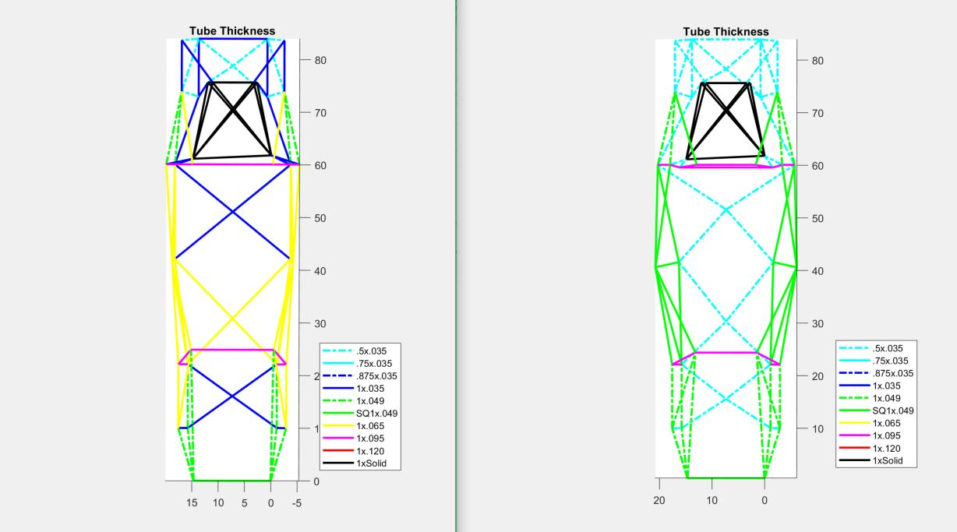

SIDE

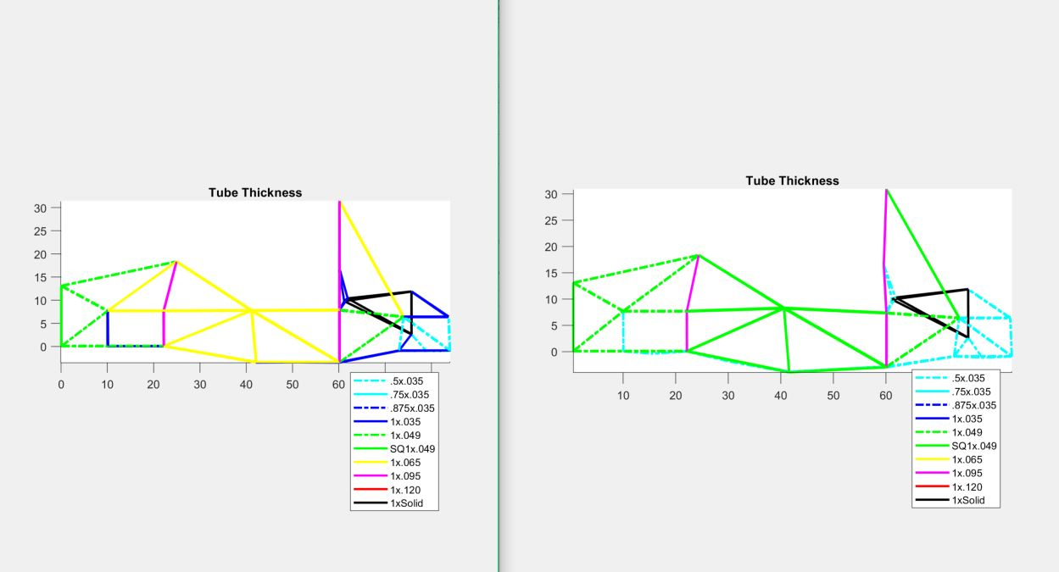

**Weight Optimizer #2**

Generation Best Ratio: 40.6241

Associated Stiffness: 2134.0005 N*m/deg

Associated Weight: 52.5304 lbs

ISO

